- Build a text input with `useState` that shows a live preview of typed text.
Coding:
import { useState } from "react";
function Livetext(){
const [text,setText] = useState("");

return(
<>
<h1>Live Preview : <span id="p">{text}</span></h1>
<br></br>
<input type="text" value={text} onChange={(e) => setText(e.target.value)}/>
</>
);
}

export default Livetext;

Output:
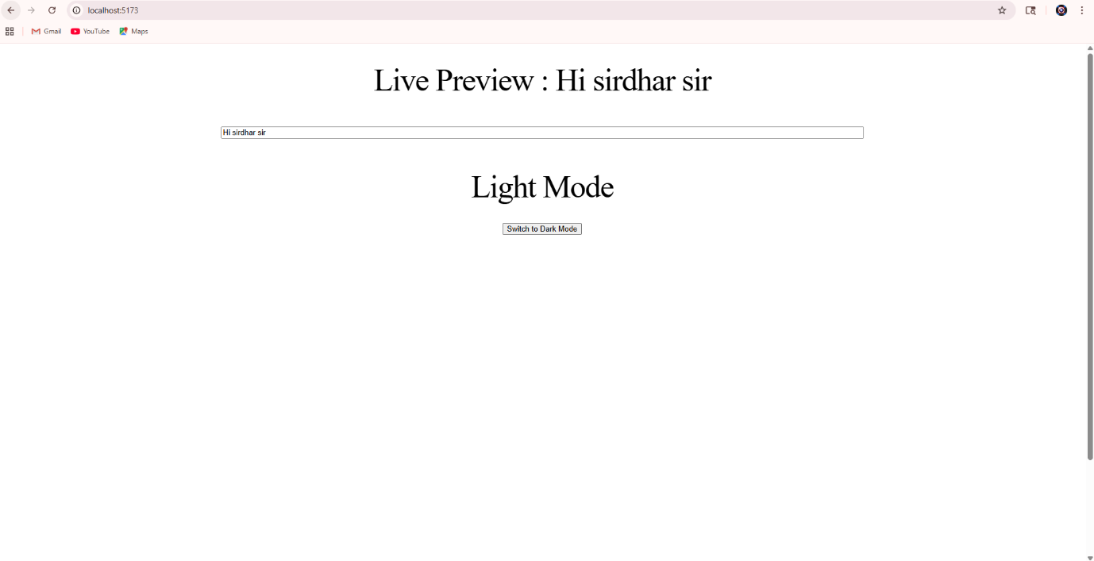
- Add a toggle switch using `useState` to switch dark/light mode styles.
Coding:
import { useState } from "react";

function Toggle() {
const [darkMode, setDarkMode] = useState(false);

return (
<div
style={{
backgroundColor: darkMode ? "#222" : "#fff",
color: darkMode ? "#fff" : "#000",
minHeight: "100vh",
padding: "20px",
transition: "0.3s",
}}
>
<h1>{darkMode ? "Dark Mode" : "Light Mode"}</h1>

<button onClick={() => setDarkMode(!darkMode)}>
Switch to {darkMode ? "Light" : "Dark"} Mode
</button>
</div>
);
}
export default Toggle;

Output:
